**Lab 7**

**Speech and Image Processing**

**Group Members**

**Abdul Ghaffar Kalhoro -------------------- (194699)**

**Hamad Nasir ---------------------------------- (120312)**

**Muhammad Rehman Rabbani ---------- (137364)**

Using MATLAB or Octave, perform the following tasks

**Part (a)** 2 marks

**Save the following MATLAB code in a file called distribution1.m and indent it properly. Then run it.**

**for i=1:1000 r1=rand(); t1=rand()*2*pi; x(i)=3+r1*cos(t1); y(i)=2+r1*sin(t1)/4; end; plot(x',y','.')**

**Write in a few sentences what is happening in the above code. Save the graph in the form of an image (jpg or png) file.**

**Solution:**

In this code, the x and y coordinate values are plotted through random numbers as input, where x and y are founded by two different variables. Where the total generated data is from 1 to 1000 and is based on two equations of x and y.

**Part (b)** 2 marks

**Write code to calculate mean vector and covariance matrix for the above distribution of 2-dimensional vectors**

**Part (c)** 2 marks

**Is this distribution normal distribution? Justify your answer.**

**Solution:**

No, The distribution is not normal because the data is scattered and is not symmetric or centered about the mean. In the above distribution, we cannot make sense of which data is frequent then the other.

**Part (d)** 2 marks

**Modify the code so that it generates an approximately normal distribution. Use rand() function only and not any other high-level normal distribution random number generator.**

**Hint: Look up central limit theorem**

**Part (e)** 2 marks

**The covariance matrix for Part (a) would have large values on the diagonal and very small values off diagonal, since the distribution is axis aligned. Write code to create a distribution that is not axis aligned and hence has significant values in off-diagonal entries of the covariance matrix. Calculate mean vector and covariance matrix for these 2-dimensional vectors.**

**Source Code:**

% Part (a)

for i=1:1000

r1=rand();

t1=rand()*2*pi;

x(i)=3+r1*cos(t1);

y(i)=2+r1*sin(t1)/4;

end;

figure = plot(x',y','.');

saveas(figure,'graph1.png');

% Part (b)

C = cov(x,y);

mx = mean(x);

my = mean(y);

mn = mean([x; y], 2);

C

% Part (d)

for i=1:1000

r1=rand();

t1=rand()*2*pi;

r = log(r1);

t = log(t1);

x1(i)=3+r*cos(t);

y1(i)=2+r*sin(t)/4;

end;

figure2 = plot(x1',y1','.');

saveas(figure2,'normalized_graph.png');

%Sd = sum(x1,'double');

n = length(x);

Sx = (1 /(n-1)) .* (x' - mx) * (x' - my)';

Sy = (1 /(n-1)) .* (y' - mx) * (y' - my)';

%histfit(mean(Sx));

figure5 = histfit(mean(Sy));

%part (e)

for i=1:1000

r1=rand();

t1=rand()*2*pi;

x6(i)=r1*cos(t1);

y6(i)=r1*sin(t1);

end;

figure3 = plot(x6',y6','.');

saveas(figure3,'graph2.png');

**OUTPUT:**

**Task (a)**

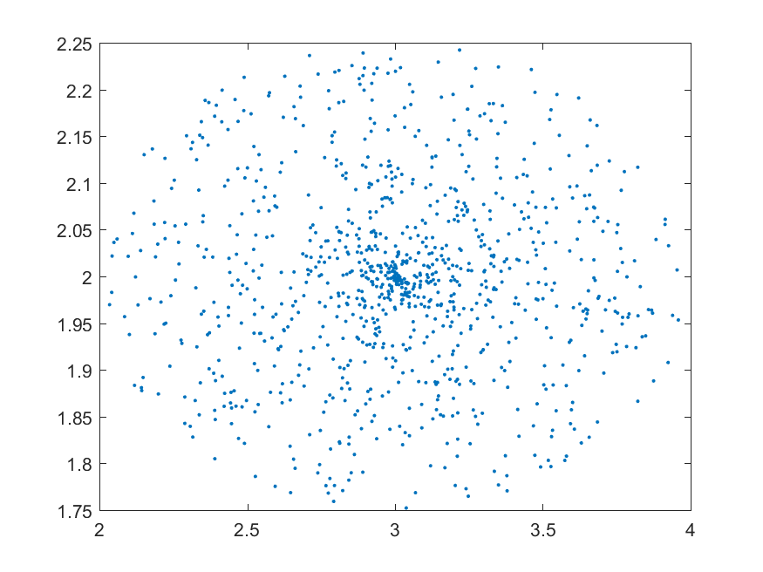

**Task(d)**

